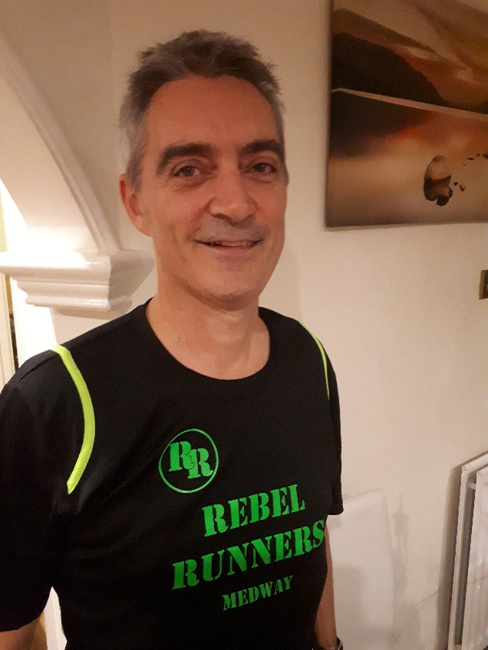
I’d never run outside of playing sport before, so we were both a bit anxious when we went to register at the beginning of January. However, I shouldn’t have worried. Everyone was very friendly and supportive.
What struck me immediately is that I couldn’t believe that so many people had given up their time voluntarily to help others get healthy and fit. In fact, their support meant that I felt very committed to finishing the programme.
The Rebel Runners Couch to 5K, as well as involving sessions every Saturday morning, also provides ‘homework’ sessions during the week to speed up progress. As I work in London, I couldn’t get back in time for these sessions but as was able to follow the instructions and go out later on my own which worked pretty well.
Graduation was at the Great Lines Parkrun in Gillingham. What I didn’t realise is that Parkrun is in no way a race! When you turn up you see people of all abilities, children in buggies, 85 year olds – a real cross section! There’s really no need to worry how fast you are, some people walk, some are very fast, but most are somewhere in between.
We were all paired up with someone from the Rebel Runners Club for the graduation day run, which again was very encouraging. In fact, may of the club members started their running hobby via a couch to 5K programme and now enjoy being active participants in the club.
Since graduation I’ve kept the hobby going and noticed many health benefits. However, doesn’t have to be an obsession, nor is it overly expensive or time consuming. I don’t run if the weather is bad, but its kept me fit and active all year. I’ve now completed 14 Parkruns and although time most certainly isn’t everything, I’m really proud that I have improved my best time by over 10 minutes!
And to cap everything off I’ve even joined the Rebel Runners!

